2024 DBIA-WPR Website Sponsor Data Request

Note that all items are due by Friday, November 17, 2023.

Please send in early if possible, as your page work can be started now.

Send electronically to: admin@dbiawpr.org Please do not mail hard-copy-text.

If you are a current 2023 website sponsor and have no changes in any of the areas below, then please just indicate “RENEW - no change.”

12-month Sponsor, January to December 2024 = $1,250.00

Payment Info: Mail check to DBIA-WPR, 21520 Yorba Linda Blvd., Suite G-419, Yorba Linda CA 92887 Attn: Website

About Your Company
Company Name: ........... [REQUIRED]
Company Description (under 2000 characters including spaces): ........... [REQUIRED]
Contact Information - Primary Location [REQUIRED]
- Contact Person: ...........
- Contact Person Title: ...........
- Address: ...........
- City / State / Zip ..........
- Phone: ...........
- Fax: ...........
- Email: ...........
- Website: ...........
Contact Information - Secondary Location [OPTIONAL]
- Contact Person: ...........
- Contact Person Title: ...........
- Address: ...........
- City / State / Zip ..........
- Phone: ...........
- Fax: ...........

Company Logo
- Appears to the left of your Company Description on your individual Sponsor's Page
- Minimum 250px in the longest dimension
- Full color (transparent background is recommended)
- File format: .EPS, .TIF, .PNG, or .JPG
- File name: ...........
Your Featured Project
Your Featured Project is displayed at the top of your individual Sponsor's Page.
Featured Project Image
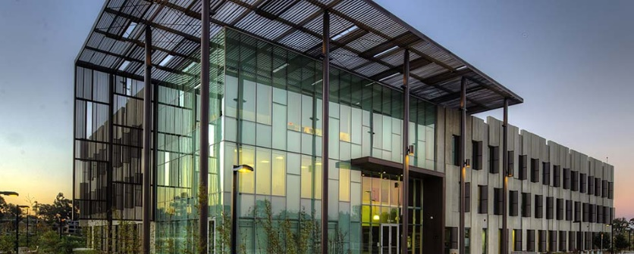
- Aspect ratio 10:4
- Minimum 1000px wide by 400px tall
- Full color
- File format: .EPS, .TIF, .PNG, or .JPG
- File name: ...........
Featured Project Details
- Featured Project Name: ...........
- Featured Project Description (max 200 characters): ...........
- Featured Project Location (City, State): ...........
- DB Firm Name [OPTIONAL]
- GC Firm Name [OPTIONAL]
- Featured Project Owner: ...........
- Featured Project Completion Date: ...........
- Type of Work (max 24 characters): ...........
- Architect: ...........
- LEED: ...........
Your Project Gallery
Up to 9 images highlighting other projects by your company. Your Project Gallery appears below the Company Description on your individual Sponsor's Page.
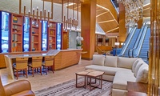
- Aspect ratio 8:5
- Minimum 640px wide by 400px tall
- RGB color only
- File format: .EPS, .TIF, .PNG, or .JPG
Image 1:
- File name: ...........
- Caption (max 100 chars including spaces.): ...........
Image 2:
- File name: ...........
- Caption (max 100 chars including spaces.): ...........
Image 3:
- File name: ...........
- Caption (max 100 chars including spaces.): ...........
Image 4:
- File name: ...........
- Caption (max 100 chars including spaces.): ...........
Image 5:
- File name: ...........
- Caption (max 100 chars including spaces.): ...........
Image 6:
- File name: ...........
- Caption (max 100 chars including spaces.): ...........
Image 7:
- File name: ...........
- Caption (max 100 chars including spaces.): ...........
Image 8:
- File name: ...........
- Caption (max 100 chars including spaces.): ...........
Image 9:
- File name: ...........
- Caption (max 100 chars including spaces.): ...........

